(10 pts) Gene Model Checker:
  - Take a screenshot of your passed gene model checker page for your report (including both the left and right sides of the screen).
The Gene Model Checker page is divided into two main panels:
I. The left side of the screen which allows one to specify the gene model characteristics that an individual would like to verify.
II. The right side of the screen shows the results that are generated by the Gene Model Checker.
For an individual to verify a gene model, the Gene Model Checker must be provided with the project sequence file in the FORMAT of FASTA, the protein name ortholog in D. melanogaster, the name of the group and project and the coding exons coordinates in a list that is separated with a comma.

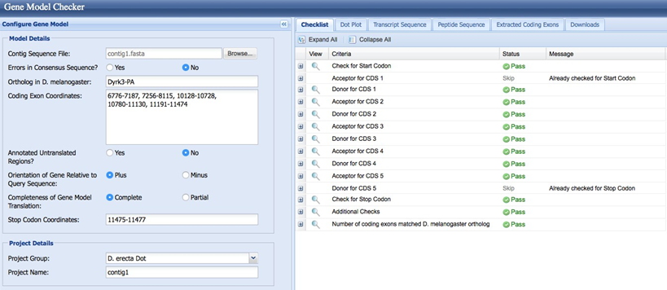

  - Explain any excused failures

(10 pts) Dot Plot
- Take a screen shot of your dot plot and paste it into your report.
Checking the dot plot and the global protein alignment
An individual you can also use the dot plot and the protein alignment in the checklist addition to verify their gene model. In order to examine the dot plot between the protein translation for their gene model and the putative D. melanogaster ortholog Dyrk3-PA in figure one below, they should click the “Dot Plot” tab.
The Dot plot alignment between the D. melanogaster protein Dyrk3-PA (x-axis) and the translation from the submitted model (y-axis) is shown in figure one. Each dot in the plot dot shows similarity regions between the two sequences.
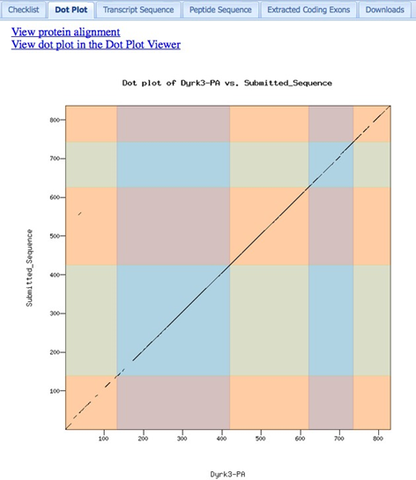
Looking at the dot plot, we see that there is a long diagonal line with a slope of approximately 1. This suggests that the two sequences have approximately the same lengths and that they are mostly similar to each other. The alternating colors in the dot plot represent the approximate location of each exon. We also see that there is weaker sequence homology at the beginning of the protein compared to the rest of the protein.
- Discuss any problems with your gene model that you have noticed from the dot plot.

An individual can click on the “View dot plot in the Dot Plot Viewer” link to view the dot plot in the Dot Plot Viewer for those gene models that show weak sequence similarity with the D. melanogaster ortholog. In order to alter the sensitivity and the specificity of the dot plot in the figure below, the Dot Plot Viewer gives a person the ability to control the dot plot alignment parameters like neighborhood, scoring matrix and word size.

To control the sensitivity of the dot plot, Change the parameters in the Dot Plot Viewer

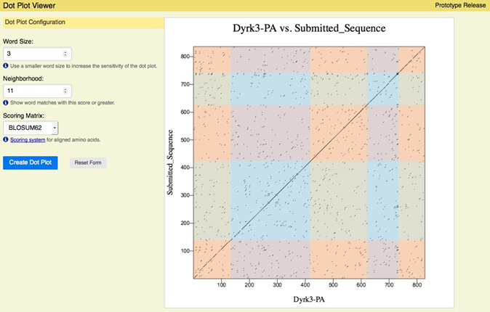

(10 pts) Protein Alignment
- take a screenshot of the sequence alignment. You may need to scroll down, and break it up into several screen shots to obtain the entire alignment.
- An individual should go back to the Gene Model Checker page.
- To see the global alignment between the two protein sequences, they should then Click the link on link “View protein alignment” to see the global alignment between the two protein sequences.
- At the beginning of the protein on the dot plot the observation of the weaker sequence homology is consistent with the global alignment.
In the figure below, there is a particular large gap at the beginning of the alignment.
Large gap at the beginning of the protein alignment between Dyrk3-PA and the submitted gene model.

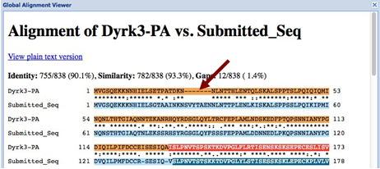

- does the overall length of your predicted sequence match well to the D. melanogaster ortholog? Are there large gaps (-------) in the alignment? If there are gaps, do these gaps map to a boundary between exons or in the middle of the exon? What can this mean?
- A large gap is in an internal part of the first CDS, after checking the blastx alignment of CDS 1_2380_0 against contig1.
- In this figure below, this gap is not caused by an error in our annotation but is likely to reflect a genuine difference between the two species.
- There is an19 bl2seq alignment between the first CDS (1_2380_0) from the D. melanogaster Dyrk3-PA (subject) and the contig1 sequence (query) shows that the D. erecta CDS has a few additional residues in its first CDS compared to its D. melanogaster ortholog according to the figure below.

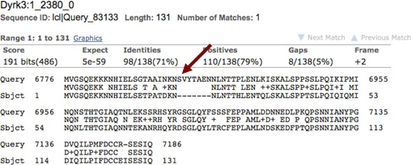

4.(10 pts) GEP UCSC Genome Browser verification
- Take of screen shot of the genome browser for your custom gene model and paste it in your report. Take three screen shots: one for the whole gene model (Custom Gene Model), one screenshot for the beginning of the gene and another for the end the gene. Annotate (with an arrow) on the gene the START CODON and THE END CODON.
- To diagnose the issue, to identify the problems with the donor and acceptor splice sites for CDS 3, the custom track feature will be used instead of using the surrounding sequence feature.
- In the figure below, an individual should click on the icon next to “Acceptor for CDS 3”.
- A new window displaying the GEP UCSC Genome Browser view of this region will open.

Genome Browser view of the putative acceptor site for CDS 3

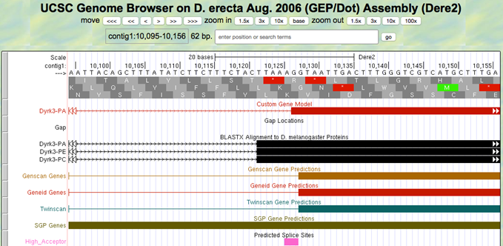
From the Genome Browser view there is an observation that the gene model that is shown under “Custom Gene Model” the track title by a single nucleotide is different from the blastx track and the other gene predictors like Geneid, Genscan and Twinscan.At 10126- 10127 which is 1bp away from our annotated splice site, there is also a high-quality splice acceptor site . Instead of the canonical “AG” splice acceptor site, there is also an observation that the CDS 3 in our model has an “AA” splice acceptor site. The conclusion that can be made based on the evidence have collected, is that a mistake when annotating the acceptor site for CDS 3: CDS 3 instead of 10127 should begin at position 10128.
There will be an examination for the exon 3 donor, after the acceptor for CDS 3 problem identification which also fails the Gene Model Checker Checklist. In the figure below, an individual should close the window and click on the icon next to “Donor for CDS 3” to have a new window opened that displays this region’s the GEP UCSC Genome Browser view. The figure below also shows the blastx alignment evidence and an open reading frame that extends beyond our annotated CDS is showed by the other gene predictors.

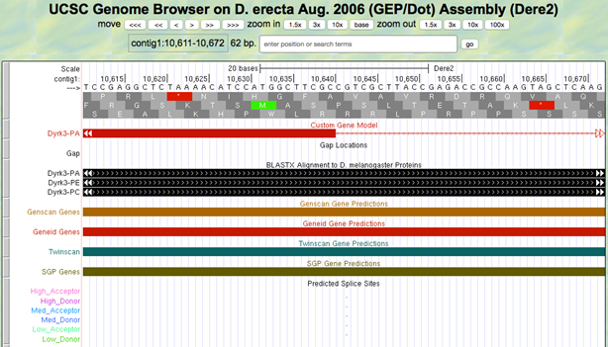
There is a potential problem with the gene model in this region according to the Genome Browser view. There is an indication that CDS 3 should be substantially longer than this model according to the blastx D. melanogaster protein alignment and results from multiple gene predictors. In order to verify that the CDS coordinates have been correctly identified, there is a need for the researcher to go back to the bl2seq alignments and gene prediction results. According to the figure below, from the alignment, there is an observation that CDS 3 should end at around 10727, after running bl2seq of the corresponding CDS from Dyrk3 in D. melanogaster (3_2380_0) against contig1. The figure below also shows bl2seq (blastx) alignment between D. melanogaster CDS Dyrk3:3_2380_0 and the display that CDS 3 should end at around 10,727 is showed by contig1.

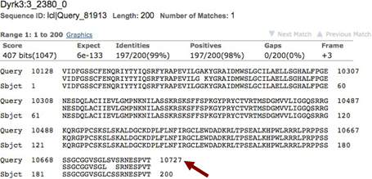
After using the genome browser, the examination shows that the region surrounding 10727 gives a chance of concluding that that instead of 10,640, the CDS should actually end at 10728.

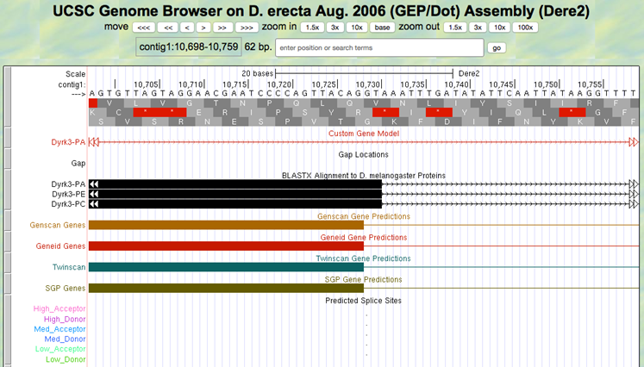

According to the suggestion, the analysis shows that the CDS 3 to 10128-10728 coordinates should be revised. To check the new gene model, one should click “Verify Gene Model”. In the checklist, according to the figure below, there is an availability of a gene model that passes all the validation tests. The final gene model passes all the items on the Checklist after fixing all the CDS 2 and CDS 3 problems in the figure below.

4.(10 pts) Conclusions
What do you conclude about your gene in terms of
    - Number of exons related to its orthologue in melanogaster
    - The identity and similarity related to its orthologue in melanogaster
    - Did the gene diverge from its orthologue in melanogaster?
    - How useful was the melanogaster gene model in figuring out the gene model for your isoform in the D. ananassae contig?

